Complete the following projects and challenge exercises.

**There are 3 challenge exercises, each worth 33.3%**

**Project #1 (Using the while loop and reading from files). >> be sure to download the Sales Data text file from Canvas**

**Place a non-numeric data in the file and run the program.**

**Challenge Exercise #1:** Complete the following below, note use only 1-10, hint use either the file writer or the print writer.



**#1 print screen the output with the code below here.**

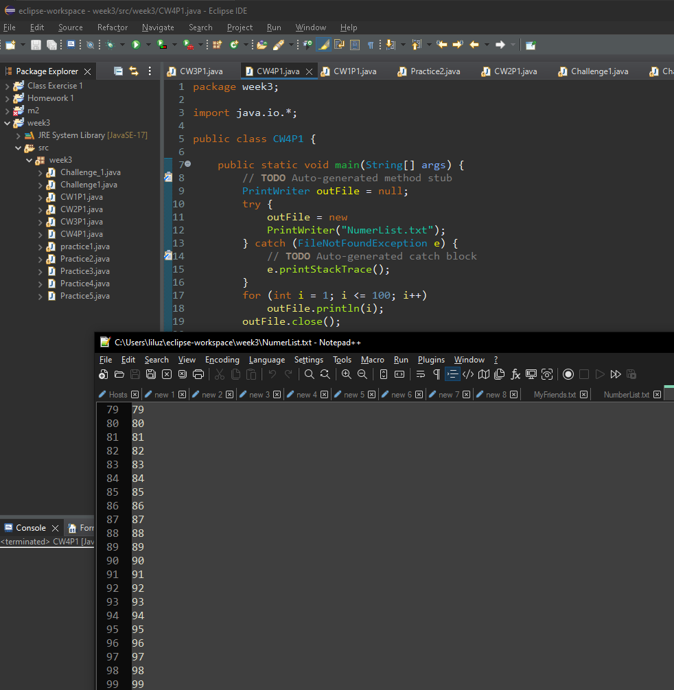

**Project #2 (Using the for loop).**

**Project #3 (Using the for loop with a Scanner).**

**Challenge Exercise #2:** Complete the following below

**#2 print screen the output with the code below here.**

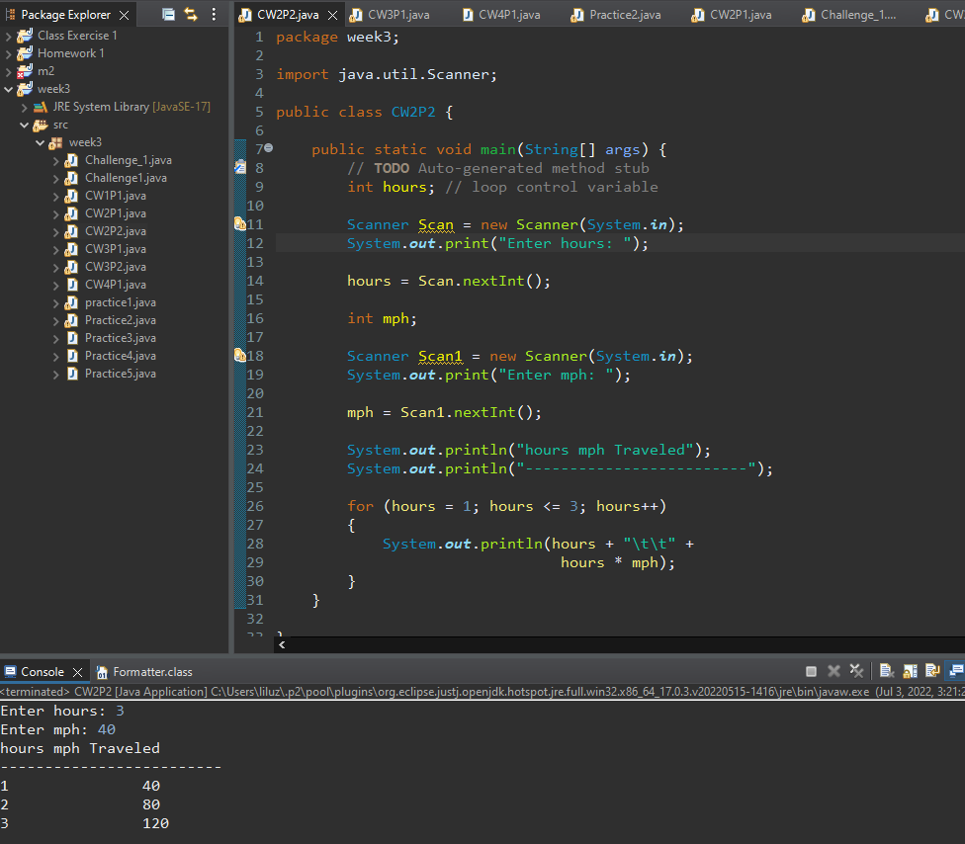

**Project #4 (Using the for loop).**

**Project #5 (Using the for loop with the JOption Pane).**

**Project #6**

**Challenge Exercise #3:** Complete the following below

**#3 print screen the output with code below here.**

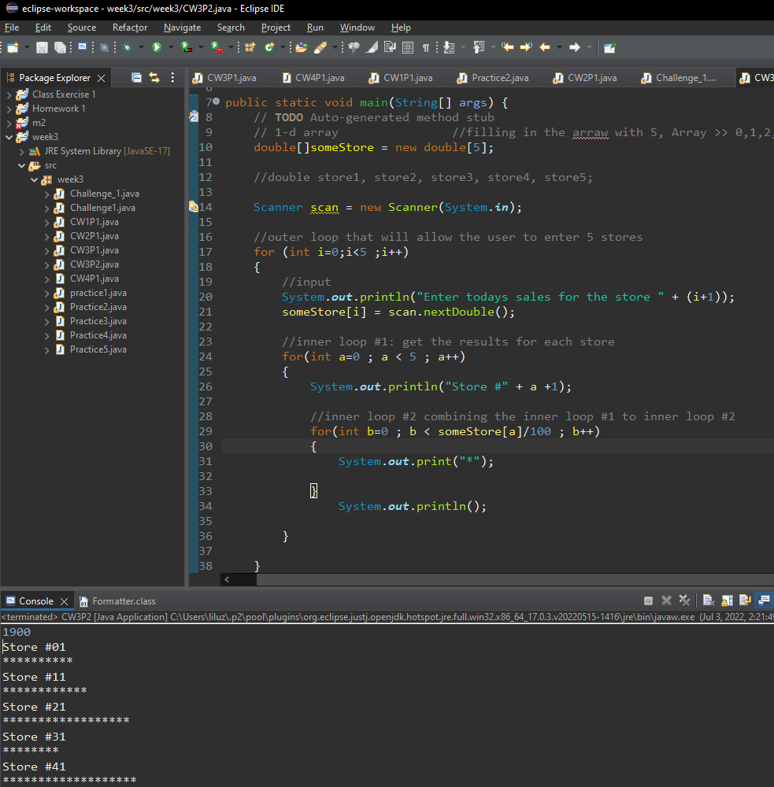

**Project #7**

**Project #8 (Random Generator)**

**Submit this document to Module 3 Class Exercise**